**1. SQL Exercise - Advanced concepts**

**Exercise 1: Ranking and Window Functions**

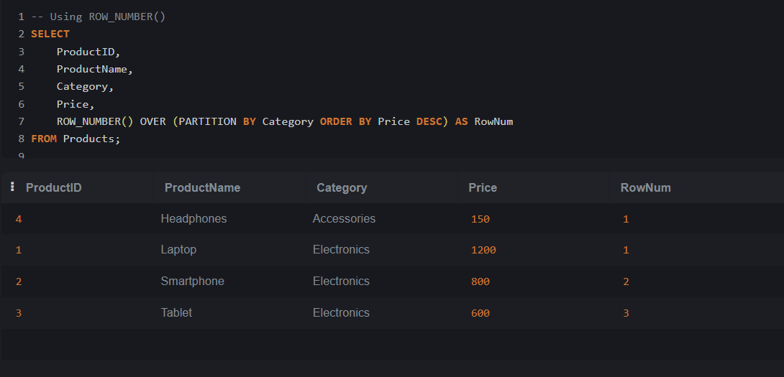

**2. SQL Exercise - Index**

**Exercise 1: Creating a Non-Clustered Index**

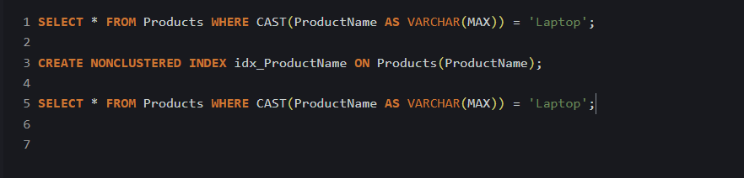

**Exercise 2: Creating a Clustered Index**

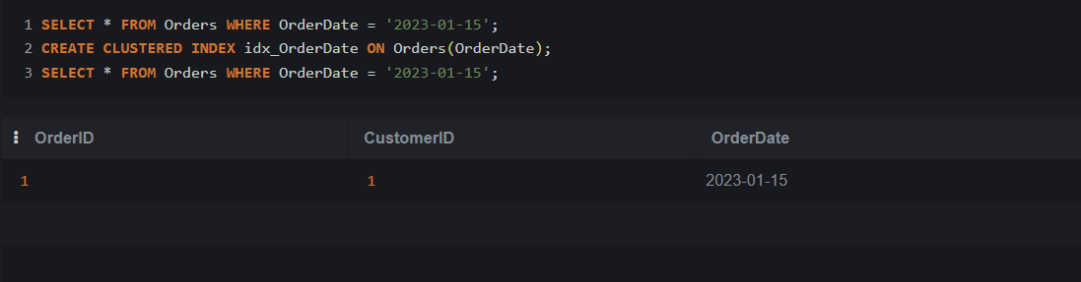

**Exercise 3: Creating a Composite Index**

**4. SQL Exercise - Stored procedure**

**Exercise 1: Create a Stored Procedure**

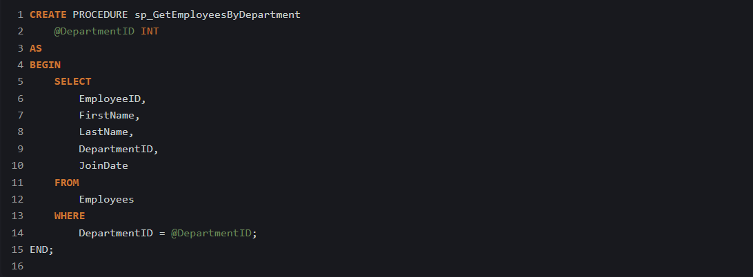

**Exercise 4: Execute a Stored Procedure**

**Exercise 5: Return Data from a Stored Procedure**

**5. SQL Exercise – Functions**

**Exercise 7: Return Data from a Scalar Function**

